Jorian Bruslind

2/7/19

ECE 342 - Blue 1 | AC Bluetooth Switch

Prof. Shuman

Interface & Property Definition Table for AC Bluetooth Switch Case

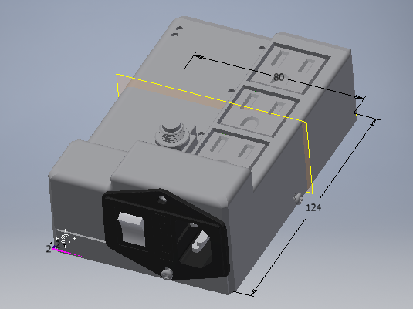

**Fig. 1.** Render of Case

This is our enclosure for our AC Bluetooth switch. It is fully 3D printed using PLA plastic, which will have a total print time of roughly 12 hours. The goal for this case was to ‘ruggedly’ enclose the system, which has been specified as not allowing anything bigger than a pencil be able to pass through. Furthermore, all wire connections to the PCB going through the enclosure (entering or leaving) must use connectors.

The case exposes a NEMA-15R compliant input plug to receive power from the wall, a physical on/off switch, and three output channels to plug NEMA-15R components into that you wish to power. Every other component of the project is enclosed by the 124mm x 80mm x 50mm case. The custom PCB is held on four standoffs, while the top of the case is mated to the bottom via four M3 screws.

**Table 1.** Interface Definitions

|  |  |
| --- | --- |
| outside_to_system_acpwr | NEMA-15R compliant  VNominal: 120VACRMS  VMin: 0V  Physical cutoff switch |
| system_to_outside_acpwr | NEMA-15R compliant  VNominal: 120VACRMS * 3 channels  VMin: 0V * 3 channels |

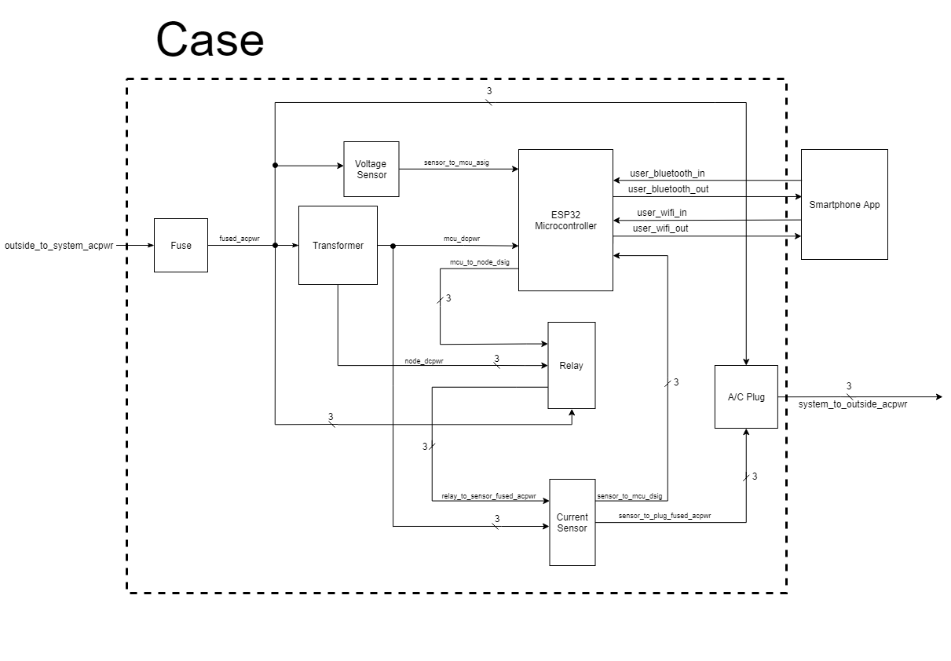

**Fig. 2**. High Level Block Diagram of System

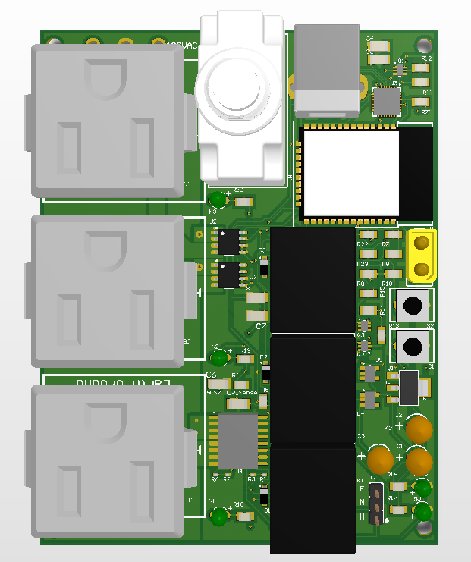

**Fig. 3.** Render of the PCB to be enclosed

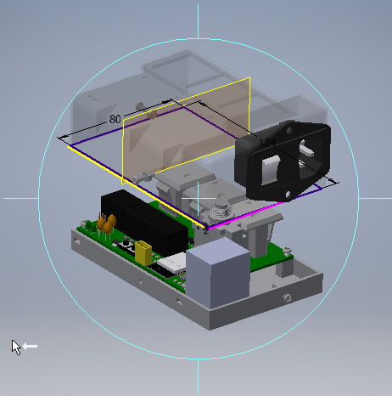

**Fig. 4.** Isometric Exploded View of the Case

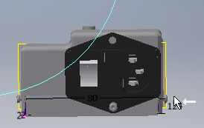

**Fig. 5.** Side View of the Case

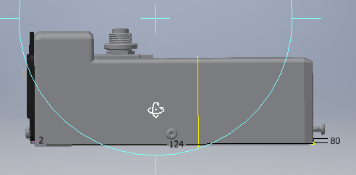

**Fig. 6**. Rotated Side View of the Case

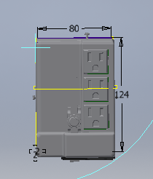

**Fig. 7.** Top View of the Case